Don’t Feed the Phish!

* Read E-mail addresses carefully
* Don’t click on unknown links
* Always report suspicious activity

Phishing attempts are tricks people use to steal your information. They take the name of large businesses like Chase, Amazon, or PayPal. Always check the sender’s information, the differences between real companies and scammers can be subtle. Help others not get scammed by always reporting suspicious activity.

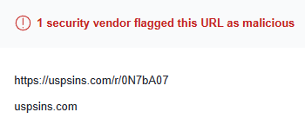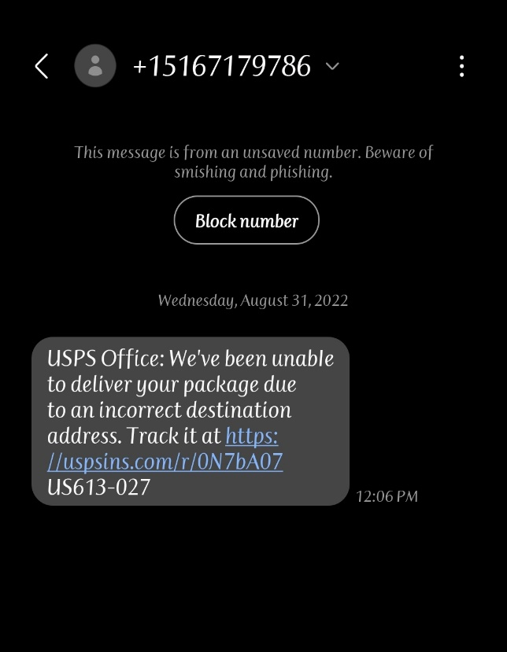

Check Links at **virustotal.com**

Beware of suspicious links!

Report phishy activity at **www.ic3.gov**